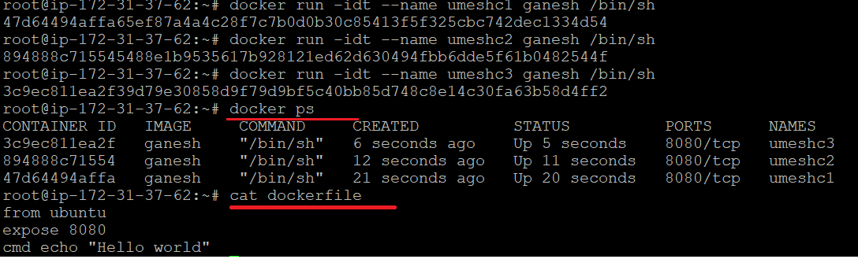

There are very less chances for port conflict as all container will get their own network, but port needs to be change for host, else we would be getting runtime exception.

docker: Error response from daemon: driver failed programming external connectivity on endpoint umeshc32 (28e0f43206ec8f1e3ee152f4fde294dde54c3a19cc6371189fc06238176a1d4b): Bind for 0.0.0.0:8080 failed: port is already allocated.

